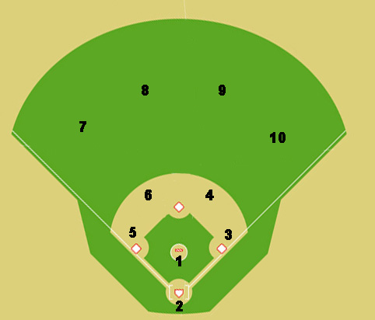
.
x
x

Situation #1: One out, runner on second base. The ball (red dot is ball) is hit to the pitcher. Where does everyone go and where do you throw the ball?

