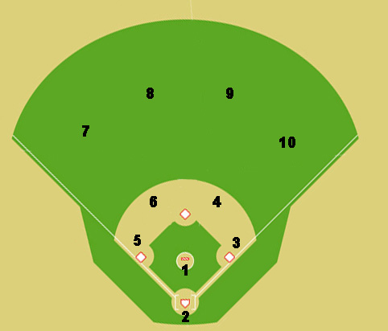
.
x

x

Situation #2: Two outs, runner on first base. The ball is hit to second (red dot is ball). Where does everyone go and where do you throw the ball?

