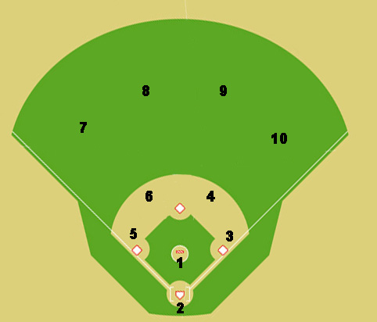
.

x

x

x

Situation #5: One out, runners on first base and second base. The ball is hit to right field (red dot is ball). Where does everyone go and where do you throw the ball?

