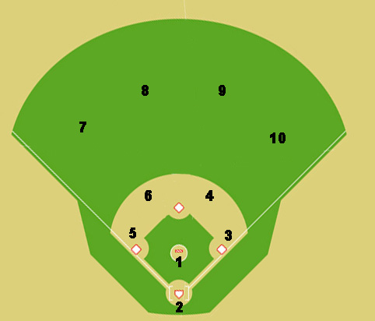
.

x

x

Situation #6: No outs, runner on second base. The ball is hit to shortstop (red dot is ball). Where does everyone go and where do you throw the ball?

