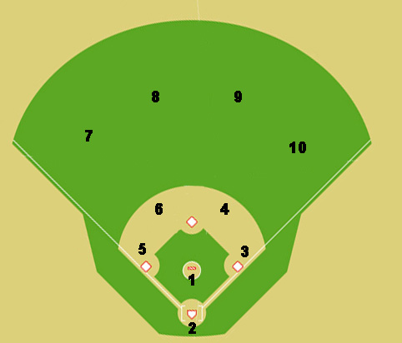
.

x

x

Situation #7: No outs, runner on first base. The ball caught in the air in left field for an out (red dot is ball). Where does everyone go and where do you throw the ball?

